DATA STRUCTURES LECTURE NOTES

DATA STRUCTURES(18CS202)
OBJECTIVES:  The course should enable the students to :  - Demonstrate familiarity with major algorithms and data structures.  - Choose the appropriate data structure and algorithm design method for application.  - Determine which algorithm or data structure to use in different scenarios.  - To improve the logical ability. |  | a specified
UNIT-I | INTRODUCTION TO ALGORITHMS AND DATA  STRUCTURES | Classes:12
Algorithms: Definition, Properties, Performance Analysis-Space Complexity, Time Complexity,
Asymptotic Notations.Data structures: Introduction, Data Structures types, DS Operations.
UNIT-II | STACKS AND QUEUES | Classes:12
Stacks: Introduction, Stack Operations, Applications: Infix to Postfix Conversion, Evaluation of
Postfix Expression.ueues: Introduction, Operations on queues, Circular queues, Priority queues.
UNIT-III | LINKED LISTS AND APPLICATIONS | Classes:12
Linked lists: Introduction, Singly linked lists, Circular linked lists, Doubly linked lists, Multiply linked lists, Applications: Polynomial Representation.Implementation of Stack and Queue using
linked list.
UNIT-IV | SORTING AND SEARCHING | Classes:12
Sorting: Introduction, Selection sort, Bubble sort, Insertion sort, Merge sort, Quick sort, Heap
Sort.Searching: Introduction, Linear search, Binary search, Fibonacci search.
UNIT-V | TREES AND BINARY TREES | Classes:12
Trees: Introduction, Definition and basic terminologies, Representation of trees.
Binary Trees: Basic Terminologies and Types, Binary Tree Traversals, Binary Search Trees.
Text Books:
- G.A.V PAI, Data Structures and Algorithms, Concepts, Techniques and Applications, Volume1, 1stEdition, Tata McGraw-Hill, 2008.
- Richard F. Gilberg& Behrouz A. Forouzan, Data Structures, Pseudo code Approach with
C, 2ndEdition, Cengage Learning India Edition, 2007.
Reference Books:
- Langsam,M. J. Augenstein, A. M. Tanenbaum, Datastructures using C and C++, 2nd Edition, PHI Education, 2008.
- Sartaj Sahni, Ellis Horowitz, Fundamentals of at Structures in C, 2nd Edition,
Orientblackswan, 2010.
Web References:
- https://www.geeksforgeeks.org/data-structures/
- https://www.programiz.com/dsa
- https://www.w3schools.in/data-structures-tutorial/intro/
Outcomes:
At the end of the course students able to
- Apply Concepts of Stacks, Queues, Linked Lists.
- Develop Programs for Searching and Sorting, Trees.
- Interpret concepts of trees.
- Develop programs for Sorting and Searching.

UNIT-I
INTRODUCTION TO ALGORITHMS AND DATA STRUCTURES
Definition: - An algorithm is a Step By Step process to solve a problem, where each step indicates an intermediate task. Algorithm contains finite number of steps that leads to the solution of the problem.
Properties /Characteristics of an Algorithm:- Algorithm has the following basic properties
- Input-Output:- Algorithm takes ‘0’ or more input and produces the required output. This is the basic characteristic of an algorithm.
- Finiteness:- An algorithm must terminate in countable number of steps.
- Definiteness: Each step of an algorithm must be stated clearly and unambiguously.
- Effectiveness: Each and every step in an algorithm can be converted in to programming language statement.
- Generality: Algorithm is generalized one. It works on all set of inputs and provides the required output. In other words it is not restricted to a single input value.

Categories of Algorithm:
Based on the different types of steps in an Algorithm, it can be divided into three categories, namely
- Sequence
- Selection and
- Iteration
Sequence: The steps described in an algorithm are performed successively one by one without skipping any step. The sequence of steps defined in an algorithm should be simple and easy to understand. Each instruction of such an algorithm is executed, because no selection procedure or conditional branching exists in a sequence algorithm.
Example:
// adding two numbers Step 1: start
Step 2: read a,b Step 3: Sum=a+b Step 4: write Sum Step 5: stop
Selection: The sequence type of algorithms are not sufficient to solve the problems, which involves decision and conditions. In order to solve the problem which involve decision making or option selection, we go for Selection type of algorithm. The general format of Selection type of statement is as shown below:
if(condition) Statement-1;
else
Statement-2;
The above syntax specifies that if the condition is true, statement-1 will be executed otherwise statement-2 will be executed. In case the operation is unsuccessful. Then sequence of algorithm should be changed/ corrected in such a way that the system will re- execute until the operation is successful.

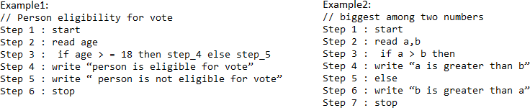
Iteration: Iteration type algorithms are used in solving the problems which involves repetition of statement. In this type of algorithms, a particular number of statements are repeated ‘n’ no. of times.
Example1:

Step 1 : start Step 2 : read n
Step 3 : repeat step 4 until n>0 Step 4 : (a) r=n mod 10
- s=s+r
- n=n/10 Step 5 : write s
Step 6 : stop

Performance Analysis an Algorithm:
The Efficiency of an Algorithm can be measured by the following metrics.
- Time Complexity and
- Space Complexity. i.Time Complexity:
The amount of time required for an algorithm to complete its execution is its time complexity. An algorithm is said to be efficient if it takes the minimum (reasonable) amount of time to complete its execution.
- ​Space Complexity:
The amount of space occupied by an algorithm is known as Space Complexity. An algorithm is said to be efficient if it occupies less space and required the minimum amount of time to complete its execution.

Write an algorithm for roots of a Quadratic Equation?
// Roots of a quadratic Equation Step 1 : start
Step 2 : read a,b,c
Step 3 : if (a= 0) then step 4 else step 5
Step 4 : Write “ Given equation is a linear equation “ Step 5 : d=(b * b) _ (4 *a *c)
Step 6 : if ( d>0) then step 7 else step8
Step 7 : Write “ Roots are real and Distinct” Step 8: if(d=0) then step 9 else step 10
Step 9: Write “Roots are real and equal” Step 10: Write “ Roots are Imaginary” Step 11: stop

Write an algorithm to find the largest among three different numbers entered by user
Step 1: Start
Step 2: Declare variables a,b and c. Step 3: Read variables a,b and c.
Step 4: If a>b
If a>c
Display a is the largest number. Else
Display c is the largest number.
Else
If b>c
Display b is the largest number. Else
Display c is the greatest number.
Step 5: Stop

Write an algorithm to find the factorial of a number entered by user.
Step 1: Start
Step 2: Declare variables n,factorial and i.
Step 3: Initialize variables factorial←1
i←1
Step 4: Read value of n
Step 5: Repeat the steps until i=n
  - : factorial←factorial*i
  - : i←i+1
Step 6: Display factorial Step 7: Stop

Write an algorithm to find the Simple Interest for given Time and Rate of Interest .
Step 1: Start
Step 2: Read P,R,S,T.
Step 3: Calculate S=(PTR)/100 Step 4: Print S
Step 5: Stop

ASYMPTOTIC NOTATIONS
Asymptotic analysis of an algorithm refers to defining the mathematical boundation/framing of its run-time performance. Using asymptotic analysis, we can very well conclude the best case, average case, and worst case scenario of an algorithm.
Asymptotic analysis is input bound i.e., if there's no input to the algorithm, it is concluded to work in a constant time. Other than the "input" all other factors are considered constant.
Asymptotic analysis refers to computing the running time of any operation in mathematical units of computation. For example, the running time of one operation is computed as f(n) and may be for another operation it is computed as g(n²). This means the first operation running time will increase linearly with the increase in n and the running time of the second operation will increase exponentially when n increases. Similarly, the running time of both operations will be nearly the same if n is significantly small.

The time required by an algorithm falls under three types −
- Best Case − Minimum time required for program execution.
- Average Case − Average time required for program execution.
- Worst Case − Maximum time required for program execution.

Asymptotic Notations
Following are the commonly used asymptotic notations to calculate the running time complexity of an algorithm.
- Ο Notation
- Ω Notation
- θ Notation

Big Oh Notation, Ο
The notation Ο(n) is the formal way to express the upper bound of an algorithm's running time. It measures the worst case time complexity or the longest amount of time an algorithm can possibly take to complete.
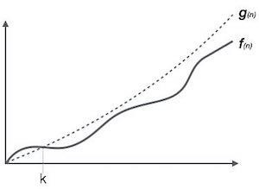
For example, for a function f(n)
Ο(f(n)) = { g(n) : there exists c > 0 and n0 such that f(n) ≤ c.g(n) for all n > n0. }

Omega Notation, Ω
The notation Ω(n) is the formal way to express the lower bound of an algorithm's running time. It measures the best case time complexity or the best amount of time an algorithm can possibly take to complete.
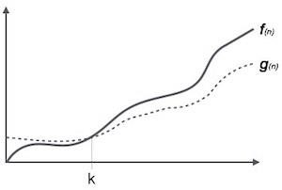
For example, for a function f(n)
Ω(f(n)) ≥ { g(n) : there exists c > 0 and n0 such that g(n) ≤ c.f(n) for all n > n0. }

Theta Notation, θ
The notation θ(n) is the formal way to express both the lower bound and the upper bound of an algorithm's running time. It is represented as follows −

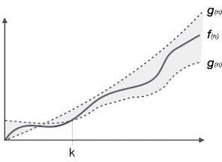
θ(f(n)) = { g(n) if and only if g(n) = Ο(f(n)) and g(n) = Ω(f(n)) for all n > n0. }

DATA STRUCTURES
Data may be organized in many different ways logical or mathematical model of a program particularly organization of data. This organized data is called “Data Structure”.

Or
The organized collection of data is called a ‘Data Structure’.
Data Structure=Organized data +Allowed operations
Data Structure involves two complementary goals. The first goal is to identify and develop useful, mathematical entities and operations and to determine what class of problems can be solved by using these entities and operations. The second goal is to determine representation for those abstract entities to implement abstract operations on this concrete representation.
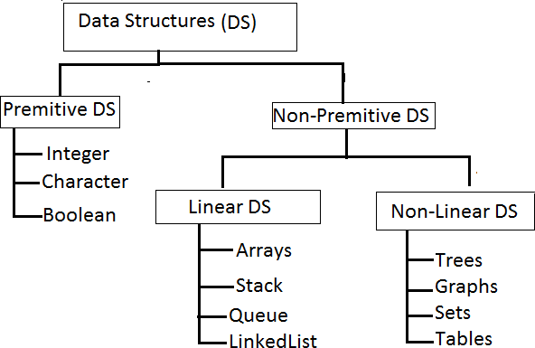

Primitive Data structures are directly supported by the language ie; any operation is directly performed in these data items.
Ex: integer, Character, Real numbers etc.
Non-primitive data types are not defined by the programming language, but are instead created by the programmer.

Linear data structures organize their data elements in a linear fashion, where data elements are attached one after the other. Linear data structures are very easy to implement, since the memory of the computer is also organized in a linear fashion. Some commonly used linear data structures are arrays, linked lists, stacks and queues.
In nonlinear data structures, data elements are not organized in a sequential fashion. Data structures like multidimensional arrays, trees, graphs, tables and sets are some examples of widely used nonlinear data structures.

Operations on the Data Structures:
Following operations can be performed on the data structures:
- Traversing
- Searching
- Inserting
- Deleting
- Sorting
- Merging
- ​Traversing- It is used to access each data item exactly once so that it can be processed.
- ​ Searching- It is used to find out the location of the data item if it exists in the given collection of data items.
- ​Inserting- It is used to add a new data item in the given collection of data items.
- ​Deleting- It is used to delete an existing data item from the given collection of data items.
- Sorting- It is used to arrange the data items in some order i.e. in ascending or descending order in case of numerical data and in dictionary order in case of alphanumeric data.
- ​ Merging- It is used to combine the data items of two sorted files into single file in the sorted form.

UNIT-II STACKS AND QUEUES

STACKS
A Stack is linear data structure. A stack is a list of elements in which an element may be inserted or deleted only at one end, called the top of the stack. Stack principle is LIFO (last in, first out). Which element inserted last on to the stack that element deleted first from the stack.

As the items can be added or removed only from the top i.e. the last item to be added to a stack is the first item to be removed.

Real life examples of stacks are:


Operations on stack:
The two basic operations associated with stacks are:
- Push
- Pop
While performing push and pop operations the following test must be conducted on the stack.
  - Stack is empty or not b) stack is full or not

- Push: Push operation is used to add new elements in to the stack. At the time of addition first check the stack is full or not. If the stack is full it generates an error message "stack overflow".
- Pop: Pop operation is used to delete elements from the stack. At the time of deletion first check the stack is empty or not. If the stack is empty it generates an error message "stack underflow".

All insertions and deletions take place at the same end, so the last element added to the stack will be the first element removed from the stack. When a stack is created, the stack base remains fixed while the stack top changes as elements are added and removed. The most accessible element is the top and the least accessible element is the bottom of the stack.

Representation of Stack (or) Implementation of stack:
The stack should be represented in two ways:
  - Stack using array
  - Stack using linked list

Stack using array:
Let us consider a stack with 6 elements capacity. This is called as the size of the stack. The number of elements to be added should not exceed the maximum size of the stack. If we attempt to add new element beyond the maximum size, we will encounter a stack overflow condition. Similarly, you cannot remove elements beyond the base of the stack. If such is the case, we will reach a stack underflow condition.
- push():When an element is added to a stack, the operation is performed by push(). Below Figure shows the creation of a stack and addition of elements using push().
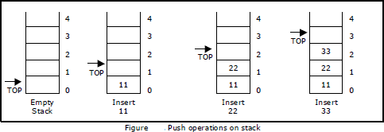
Initially top=-1, we can insert an element in to the stack, increment the top value i.e top=top+1. We can insert an element in to the stack first check the condition is stack is full or not. i.e top>=size-1. Otherwise add the element in to the stack.

void push()  {  int x;  if(top >= n-1)  {  printf("\n\nStack Overflow..");  return;  }  else  {  printf("\n\nEnter data: "); scanf("%d", &x); stack[top] = x;  top = top + 1; printf("\n\nData Pushed into the stack");  }  } | Algorithm: Procedure for push():  Step 1: START  Step 2: if top>=size-1 then  Write “ Stack is Overflow” Step 3: Otherwise  - : read data value ‘x’  - : top=top+1;  - : stack[top]=x;  Step 4: END

- Pop(): When an element is taken off from the stack, the operation is performed by pop(). Below figure shows a stack initially with three elements and shows the deletion of elements using pop().
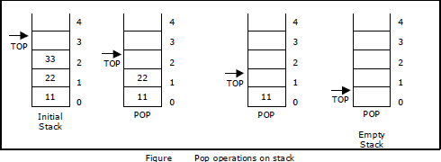

We can insert an element from the stack, decrement the top value i.e top=top-1.
We can delete an element from the stack first check the condition is stack is empty or not.
i.e top==-1. Otherwise remove the element from the stack.

Void pop()  {  If(top==-1)  {  Printf(“Stack is Underflow”);  }  else  {  printf(“Delete data %d”,stack[top]); top=top-1;  }  } | Algorithm: procedure pop():  Step 1: START  Step 2: if top==-1 then  Write “Stack is Underflow” Step 3: otherwise  - : print “deleted element”  - : top=top-1;  Step 4: END

- display(): This operation performed display the elements in the stack. We display the element in the stack check the condition is stack is empty or not i.e top==-1.Otherwise display the list of elements in the stack.
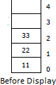
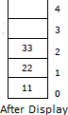

void display()  {  If(top==-1)  {  Printf(“Stack is Underflow”);  }  else  {  printf(“Display elements are:); for(i=top;i>=0;i--)  printf(“%d”,stack[i]);  }  } | Algorithm: procedure pop():  Step 1: START  Step 2: if top==-1 then  Write “Stack is Underflow” Step 3: otherwise  - : print “Display elements are”  - : for top to 0 Print ‘stack[i]’  Step 4: END

Source code for stack operations, using array:

#include<stdio.h> #inlcude<conio.h>
int stack[100],choice,n,top,x,i; void push(void);
void pop(void); void display(void); int main()
{
//clrscr(); top=-1;
printf("\n Enter the size of STACK[MAX=100]:"); scanf("%d",&n);
printf("\n\t STACK OPERATIONS USING ARRAY");
printf("\n\t ");
printf("\n\t 1.PUSH\n\t 2.POP\n\t 3.DISPLAY\n\t 4.EXIT"); do
{
printf("\n Enter the Choice:"); scanf("%d",&choice); switch(choice)
{
case 1:
{
push(); break;
}
case 2:
{
pop(); break;
}
case 3:
{

display(); break;
}
case 4:
{
printf("\n\t EXIT POINT "); break;
}
default:
{
printf ("\n\t Please Enter a Valid Choice(1/2/3/4)");
}
}
}
while(choice!=4); return 0;
}
void push()
{
if(top>=n-1)
{
printf("\n\tSTACK is over flow");
}
else
{
printf(" Enter a value to be pushed:"); scanf("%d",&x);
top++; stack[top]=x;
}
}
void pop()
{
if(top<=-1)
{
printf("\n\t Stack is under flow");
}
else
{
printf("\n\t The popped elements is %d",stack[top]); top--;
}
}
void display()
{
if(top>=0)
{

printf("\n The elements in STACK \n"); for(i=top; i>=0; i--)
printf("\n%d",stack[i]); printf("\n Press Next Choice");
}
else
{
printf("\n The STACK is empty");
}
}

Stack using Linked List:
We can represent a stack as a linked list. In a stack push and pop operations are performed at one end called top. We can perform similar operations at one end of list using top pointer. The linked stack looks as shown in figure.
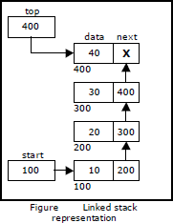

Applications of stack:
- Stack is used by compilers to check for balancing of parentheses, brackets and braces.
- Stack is used to evaluate a postfix expression.
- Stack is used to convert an infix expression into postfix/prefix form.
- In recursion, all intermediate arguments and return values are stored on the processor’s stack.
- During a function call the return address and arguments are pushed onto a stack and on return they are popped off.

Converting and evaluating Algebraic expressions:
An algebraic expression is a legal combination of operators and operands. Operand is the quantity on which a mathematical operation is performed. Operand may be a variable like x, y, z or a constant like 5, 4, 6 etc. Operator is a symbol which signifies a mathematical or logical operation between the operands. Examples of familiar operators include +, -, *, /, ^ etc.

An algebraic expression can be represented using three different notations. They are infix, postfix and prefix notations:
Infix: It is the form of an arithmetic expression in which we fix (place) the arithmetic operator in between the two operands.

Example: A + B
Prefix: It is the form of an arithmetic notation in which we fix (place) the arithmetic operator before (pre) its two operands. The prefix notation is called as polish notation.

Example: + A B

Postfix: It is the form of an arithmetic expression in which we fix (place) the arithmetic operator after (post) its two operands. The postfix notation is called as suffix notation and is also referred to reverse polish notation.

Example: A B +
Conversion from infix to postfix:
Procedure to convert from infix expression to postfix expression is as follows:
- Scan the infix expression from left to right.
- a) If the scanned symbol is left parenthesis, push it onto the stack.
  - If the scanned symbol is an operand, then place directly in the postfix expression (output).
  - If the symbol scanned is a right parenthesis, then go on popping all the items from the stack and place them in the postfix expression till the matching left parenthesis.
  - If the scanned symbol is an operator, then go on removing all the operators from the stack and place them in the postfix expression, if and only if the precedence of the operator which is on the top of the stack is greater than (or greater than or equal) to the precedence of the scanned operator and push the scanned operator onto the stack otherwise, push the scanned operator onto the stack.
The three important features of postfix expression are:
- The operands maintain the same order as in the equivalent infix expression.
- The parentheses are not needed to designate the expression unambiguously.
- While evaluating the postfix expression the priority of the operators is no longer relevant.

We consider five binary operations: +, -, *, / and $ or ↑ (exponentiation). For these binary operations, the following in the order of precedence (highest to lowest):
